**USER MANUAL  
Network Based Application Development**

**ITIS – 5166**

**Fall 2017**

**Smart Store**

**(E-Commerce Electronic Store)**

Author:

Lavina Sabhnani

801036525

**Table of Content**

Index:

Abstract

Introduction

Technological Background

System Analysis And Design

Use Case

About pages

ER Diagram

**Smart Store**

**Abstract:**

This user manual covers the design and implementation of the online retail store as ecommerce website. The website is implemented using JSPs, Servlets and consists of two main components: Admin and Customer side. Admin side consists of the features such as Adding items to the store, Modify Items in the store, Log in and Logout. Customer side consists of the features such as Select Products, Buy Items, Continue Shopping, add items to Cart, View Cart, Checkout, Sign-in, Creating an Account, Order history, and View Profile.

**1. Introduction**

The main goal of this project was to create an online retail store, which allows customers to shop and purchase the electronic products online. Moreover, the project is also designed in such a way it lets admins manage the products information.

**2. Technological Background**

The tools and technologies used to develop the online retail store include:

- JSP

- MySQL database server

- Tomcat Apache server

- HTML

- Servlets

- Net beans

Servlet technology is used to create web application (resides at server side and generates dynamic web page).

JavaServer Pages (JSP) is a technology that helps software developers create dynamically generated web pages based on HTML, XML, or other document types.

MySQL is a very fast, robust, relational database management system (RDBMS). A database enables the users to efficiently store, search, sort, and retrieve data.

Tomcat server interprets the code at the Web server and generates HTML or other output that the visitor will see.

Net beans IDE is used to write the coding in plain text that the Web server can recognize and translate into binary code.

There are advantages of using these tools to develop and run the software. Tomcat server and MySQL server are free to download from the internet if one does not have any tools.

**3. System Analysis & Design**

The system was analyzed and designed before implementation began. In this section use cases, and webpage diagrams are described in detail.

**3.1 Use Cases**

The following use cases outline the requirements for the online shopping store.

**Customer Interface**

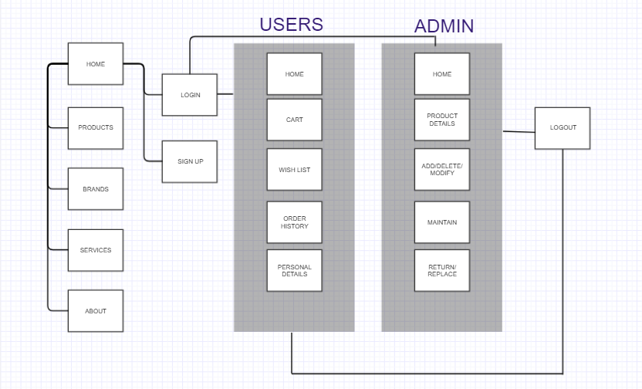

**Page Design**

**Name of the page:** Home

**Purpose of the page:** Admin/Users can login their respective accounts. Guest can use Homepage without verification. All products are visible to everyone.

**Audience of the page:** Admin, Users, Guest.

**Data fields:** Product, Brands, Company descriptions.

**Validations:** Can validate or not.

**Actions:**

* Home: Takes back to home page.
* Products: Drop down of all the products for sale.
* Top Brands: Available products segregated according to brands.
* Services: Provides customer service.
* About : Clicking on this would navigate the user to about us page where the details about the company is displayed
* Login : Clicking on this would take the user to log in page)
* FAQs: Lets users/guest ask or read through commonly asked questions.
* Sign Up: Lets guest sign up and save their details.
* 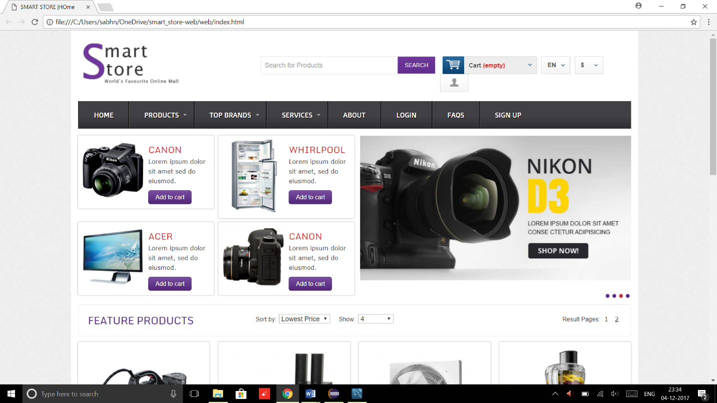

**Name of the page:** Products

**Purpose of the page:** Products page displays all the available products in the store.

**Audience of the page:** Customer.

**Data fields:** Drop down menu to Products available, link to that product.

**Validations:** OnlyAvailable products are listed.

**Actions:**

* Product Description- Clicking on this button would navigate the user to details about the product selected.
* Add to cart - Clicking on this button would add the selected item in the cart and increment the cart counter.
* Details: Will provide specifications of the product, price, details about the brand.

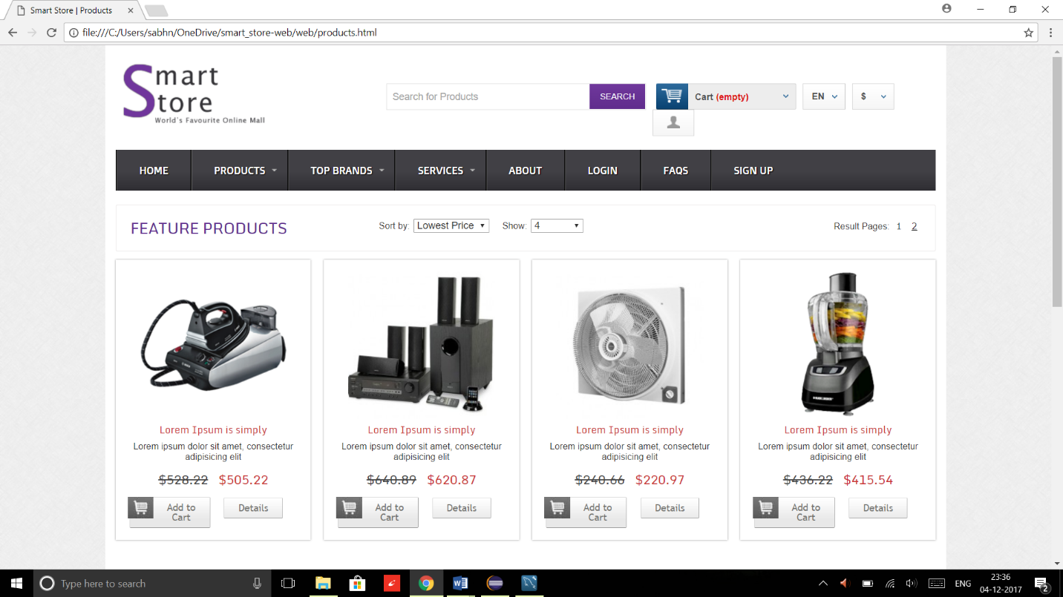

**Name of the page:** Top Brands

**Purpose of the page:** Displays most selling Brands.

**Audience of the page:** Customer.

**Data fields:** Drop down menu to Brands available, link to that brand products.

**Validations:** OnlyAvailable products are listed.

**Actions:**

* Brand Description- Clicking on this button would navigate the user to details about the brands product selected.
* Add to cart - Clicking on this button would add the selected item in the cart and increment the cart counter.
* Details: Will provide specifications of the product, price, details about the brand.



**Name of the page:** Services

**Purpose of the page:** Helps user recognize services offered.

**Audience of the page:** Customer.

**Data fields:** Service provided relating brands.

**Validations:** Onlybrands providing services are listed.

**Actions:**

* Service Description- Clicking on this button would navigate the user to details about the service selected.

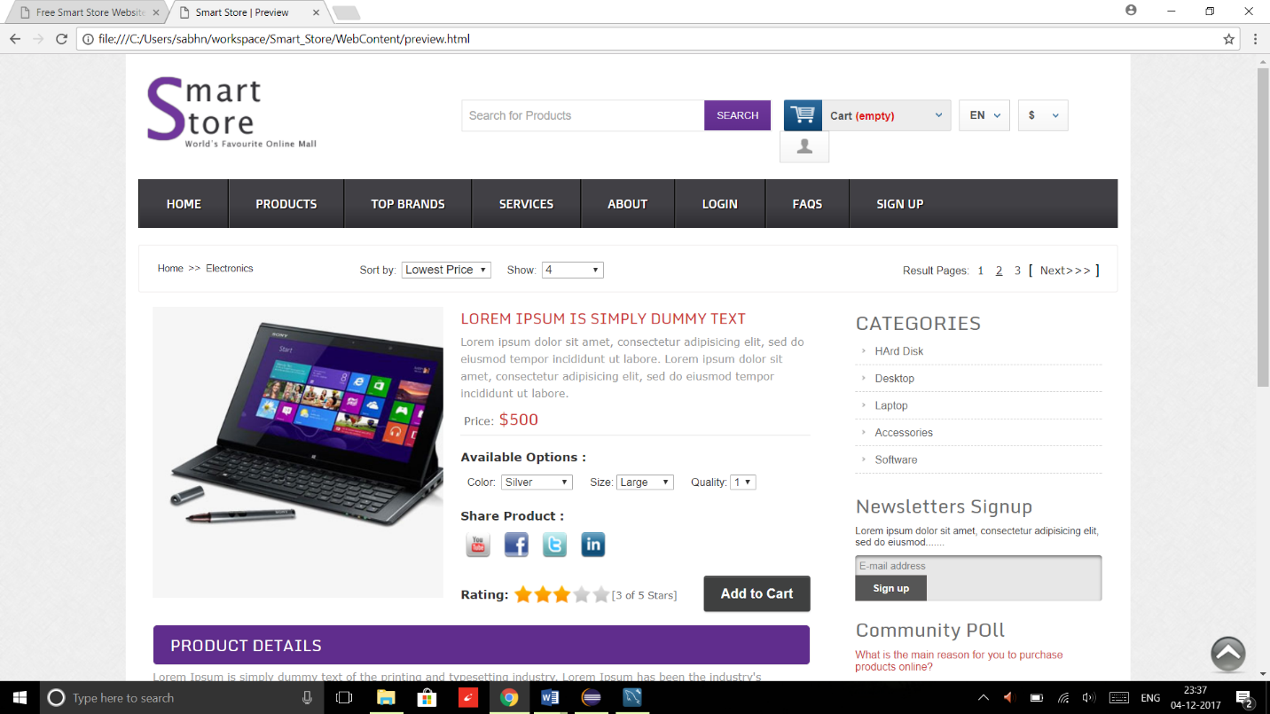

**Name of the page:** About

**Purpose of the page:** About page gives details about the online retail store.

**Audience of the page:** Customer.

**Data fields:** Details about the company.

**Validations:** No Validations

**Actions:** No actions

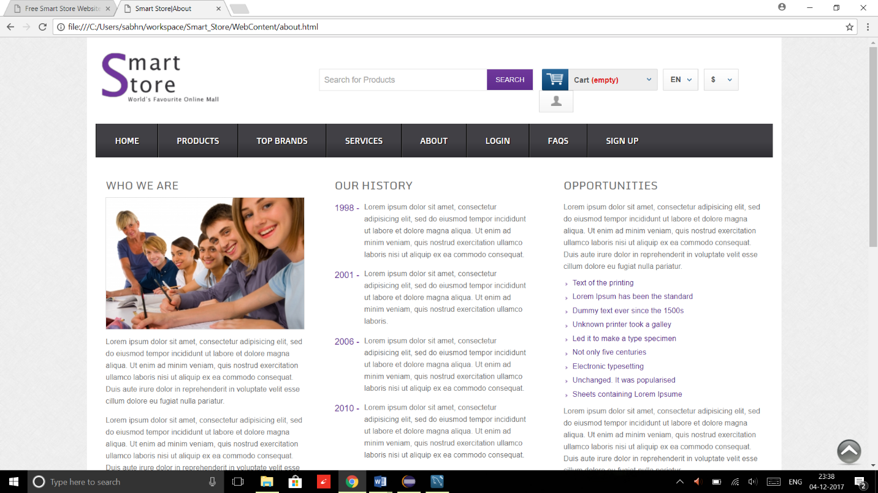

**Name of the page:** Login

**Purpose of the page:** Login page validates the users and authorizes them with their respective privileges and/or validates the admin and provides admin authorities.

**Audience of the page:** Customer and Admin.

**Data fields:** Email address and password.

**Validations:** Email address and password null checks, email address format validations and user existence in the system validations are performed and admin details are verified.

**Actions:**

* Login Admin: Links to admin page where he can perform functions like add/delete/modify details, products, brands and maintain the website
* Login User: Clicking on this button will validate the user and route them to their respective pages.
* Sign up – Clicking on this link would navigate the user to sign up page where the user can register in to the system.

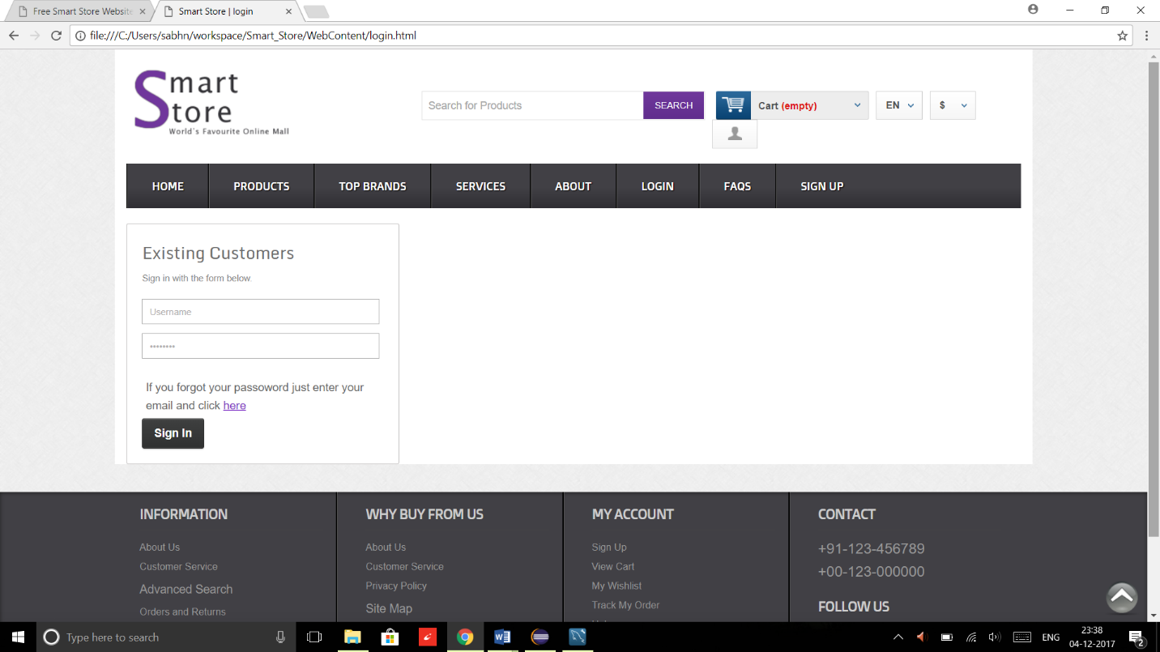

**Name of the page:** FAQs

**Purpose of the page:** FAQs page displays all the frequently asked questions, allows users to query their doubt.

**Audience of the page:** Customer.

**Actions:**

* Question: Lets user ask or read through questions.
* Admin: Allows admin to answer the queries asked.

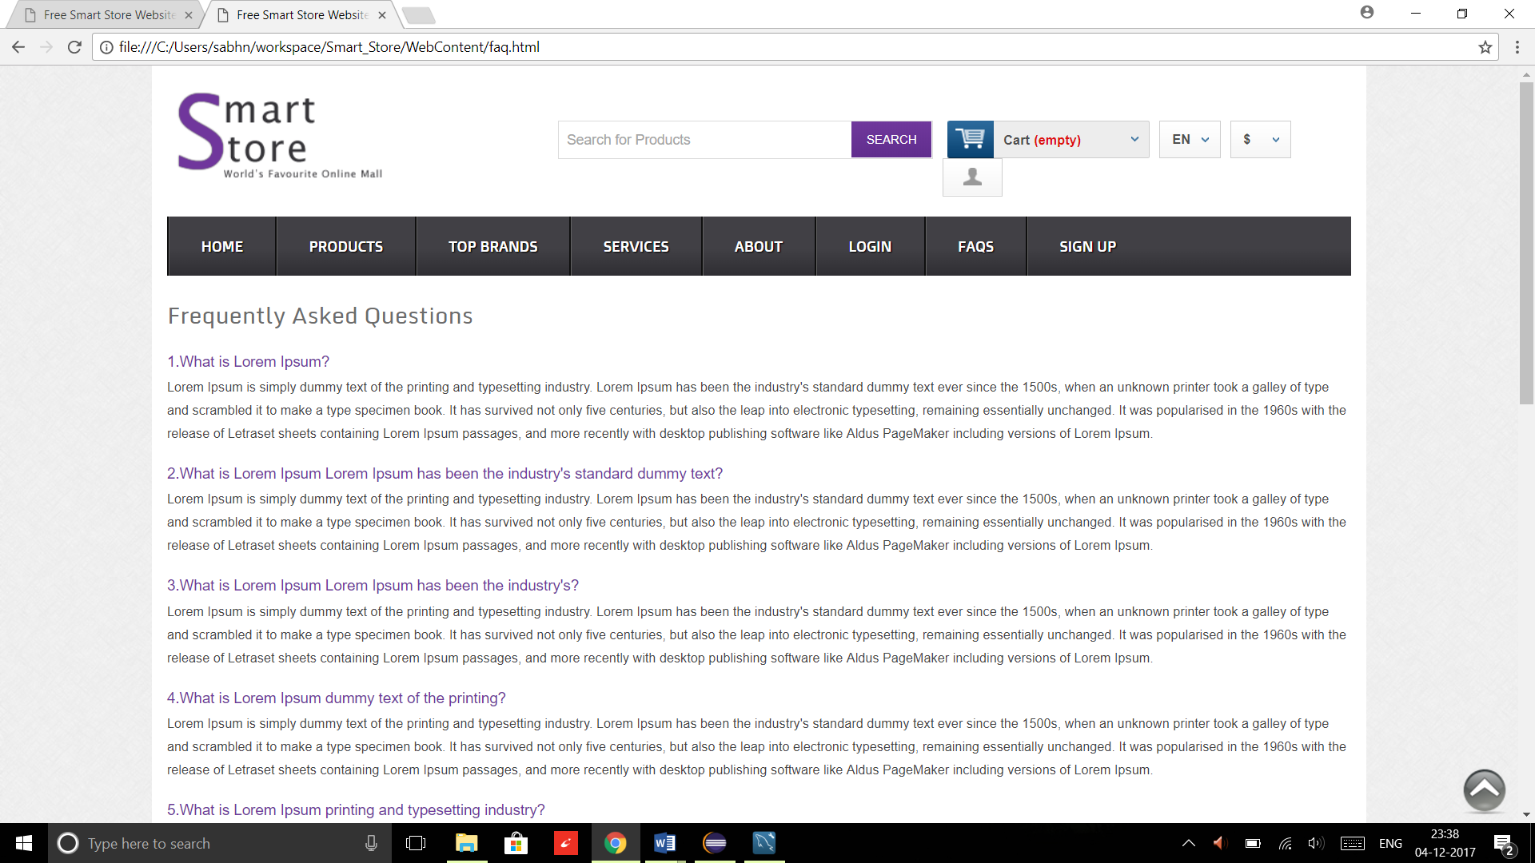

**Name of the page:** Signup

**Purpose of the page:** Signup page allows the users to register their accounts with the system.

**Audience of the page:** Customer.

**Data fields:**  Name, Email, Mobile Number, Password.

**Validations:** Null checks for all the data fields.

**Actions:**

* Sign up: Clicking on this button would register the user, if all the validations are successful and navigate the user to home.

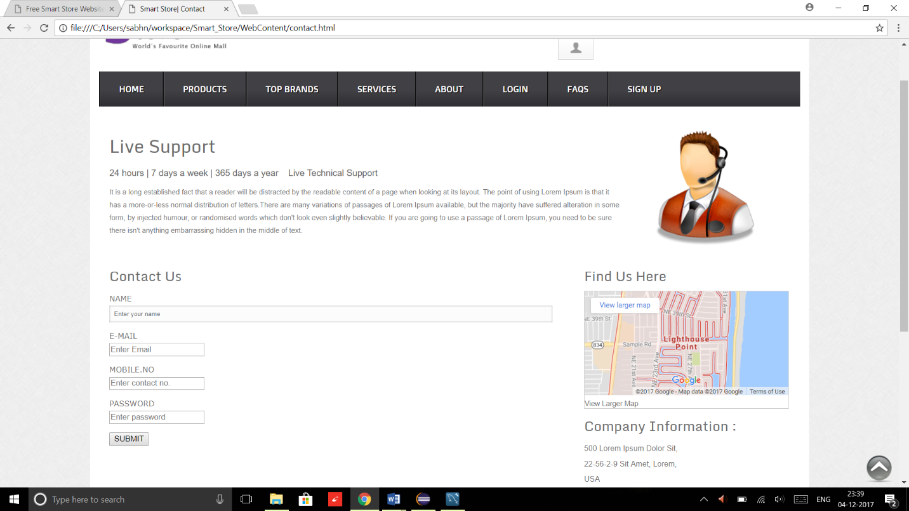

**Name of the page:** Home

**Purpose of the page:** User logs in Home page.

**Audience of the page:** Customer.

**Data fields:** A running carousel of online retail store images.

**Validations:** No Validations

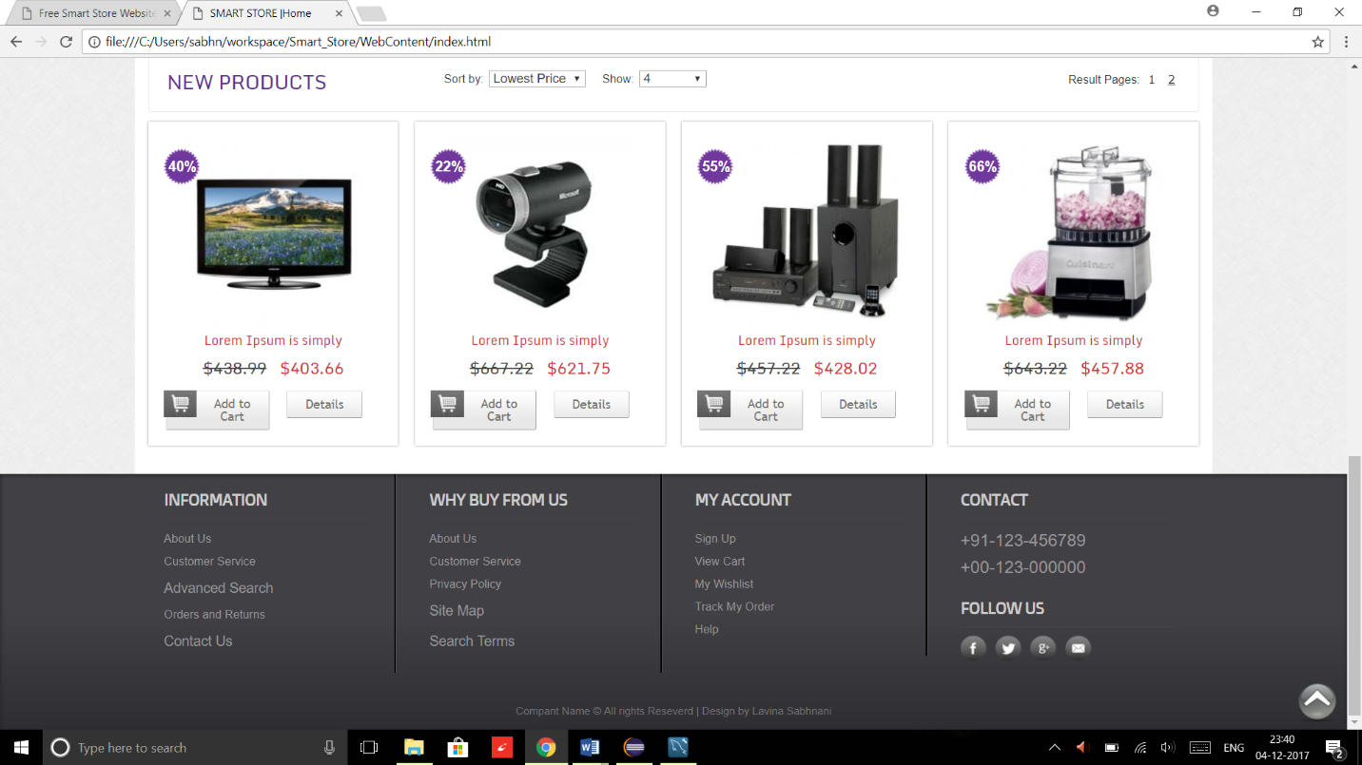

**ER diagram**

